**User Manual**

**for**

**Automated Gardening Application**

Product Developer:

Vinod Nagabhushan Rao Shivaram Samanth

**Abstract:**

This document is the Software User Manual (SUM) for the Automated Gardening Application(AGA) project. The Software User Manual (SUM) instructs how to install and use the Automated Gardening Application software. This project is part of the Object Oriented Analysis and Design course (COEN 275) at the Santa Clara University(SCU).

**Table of Contents:**

1. Introduction: 5

1.1. Intended Readership: 5

1.2. Applicability: 5

1.3. Purpose: 5

1.4. How to use this document: 5

1.5. Conventions: 5

1.6. Problem Reporting: 5

2. Overview: 6

3. Tutorial: 7

3.1. System Requirements: 7

3.2. Installing Software: 7

3.3. Uninstalling Software: 7

3.4. Quick Start: 7

4. Reference: 8

4.1. User Operations: 8

4.1.1. Installing the Application: 8

4.1.2. Landing Page of the Application: 9

4.1.3. Main Page of Application: 9

4.1.4. Edit Settings of Grid: 11

4.1.5. Random Event Window: 12

**Table of Figures:**

Figure 1: Installing Application 8

Figure 2: Landing Page of Application 9

Figure 3: Main Page of Application 9

Figure 4: Select Grid Alert 10

Figure 5: Current Status of Grid 10

Figure 6: Edit Settings Window 11

Figure 7: Random Event Window 12

1. **Introduction:**
   1. **Intended Readership:**

This document convers the use for the following users of Automated Gardening Application.

* The Garden Care Taker.
  1. **Applicability:**

This Software User Manual (SUM) applies to the Automated Gardening Application software, version 1.0.

* 1. **Purpose:**

The purpose of the SUM is to assist the user in installing and using the Automated Gardening Application software.

* 1. **How to use this document:**
* Chapter 2 gives an overview of the Automated Gardening Application software.
* Chapter 3 contains tutorials for common tasks that enable users to get started quickly.
* Chapter 4 gives a reference of the complete Automated Gardening Application software.

* 1. **Conventions:**

None.

* 1. **Problem Reporting:**

Since Automated Gardening Application is my own project, if you face any issues you can report by sending an email to me on vnagabhushanraoshivaramsamant@scu.edu.

1. **Overview:**

This software implements an application that can automate garden maintenance with minimum human interaction. This system is capable of identifying events such as rain and snow, and will disable sprinkler in order to prevent any damage to plants due to excess water flow.

1. **Tutorial:**
   1. **System Requirements:**

* A supported host operating system. Presently, we support Windows, many Linux distributions, Mac OS X, Solaris and OpenSolaris.
* Hard Disk Space: 43MB.
  1. **Installing Software:**

The Application Installer file is given only for Windows(.exe). If you don’t wish to install the application, a JAR-file is also provided so that no installation is required and runs on JVM.

* 1. **Uninstalling Software:**

The application if installed using Application Installer can be easily uninstalled using either the respective Operating System’s Application Uninstaller or any other Uninstaller Application. If the application is not installed but run using a JAR-file, you can delete the JAR-file to remove the application.

* 1. **Quick Start:**

If the application was installed using application installer, then you can start the application by simply double-clicking the application shortcut on desktop. If not, then the application can be easily started by double-clicking the provided JAR-file.

1. **Reference:**
   1. **User Operations:**
      1. **Installing the Application:**

The application can be installed by double-clicking on the provided .exe file. On running the file, once it is ready to be installed it prompts you to “Install” the application as show in the figure below.

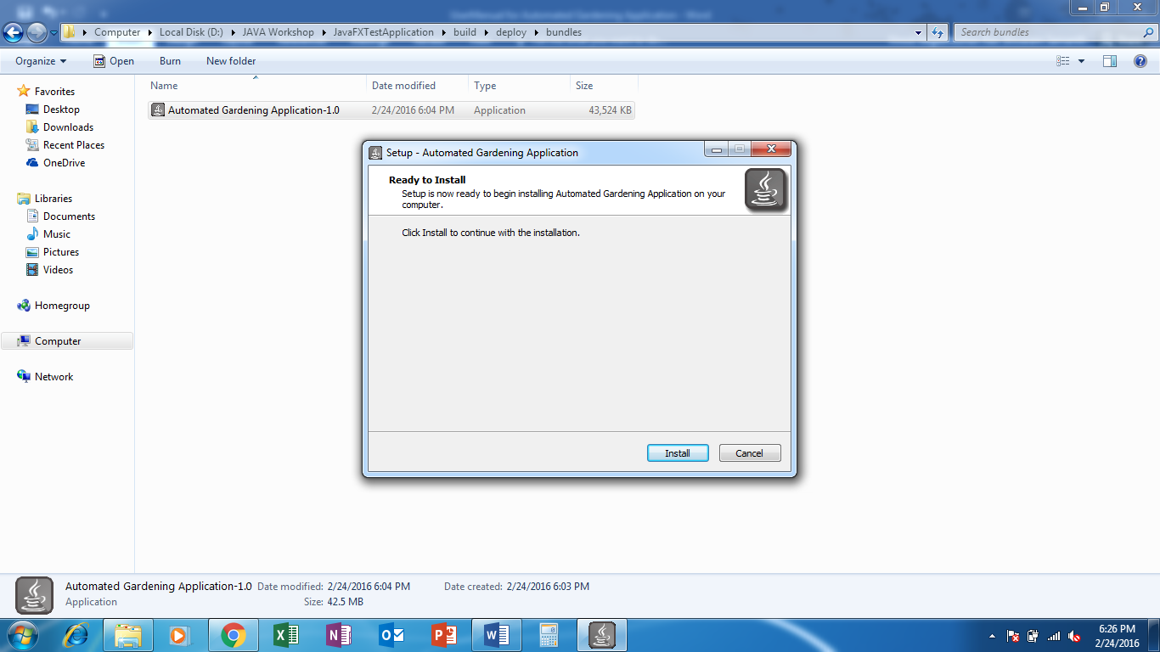

Figure 1: Installing Application

On successful installation, you’ll have a shortcut to the application on desktop.

If you choose not to install the application, then you can run the Jar-file provided.

* + 1. **Landing Page of the Application:**

The following image shows the landing stage after the application is launched. At this instance the automation of the garden hasn’t yet been started. It starts only after the “Start Application” button is clicked.

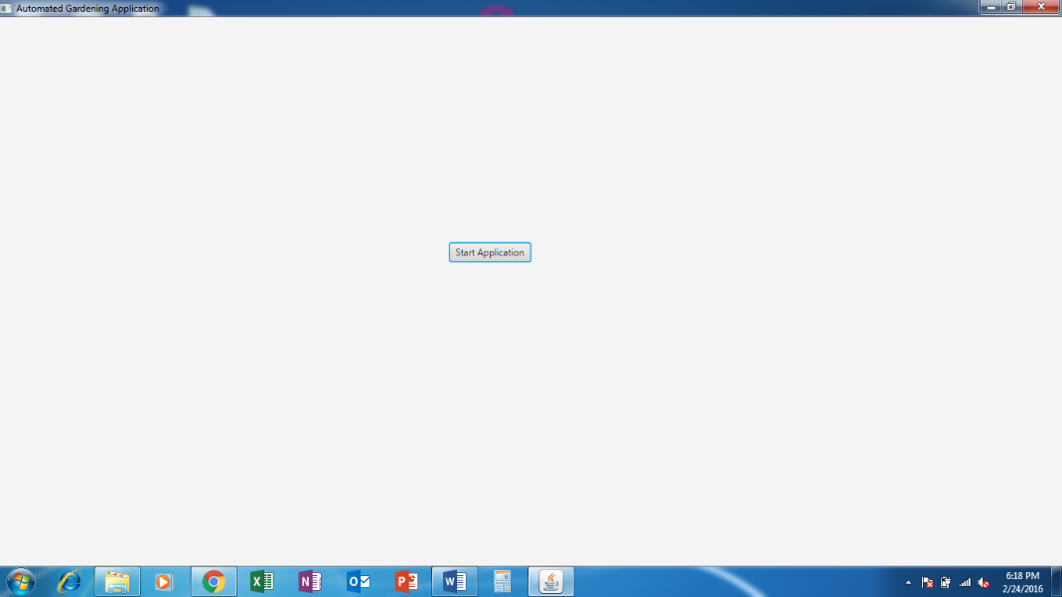

Figure 2: Landing Page of Application

* + 1. **Main Page of Application:**

Once you press “Start Application” you will be redirected to Main Page shown below. In this page you can check current status of any grid by clicking on the respective grid button on the top left of the screen.

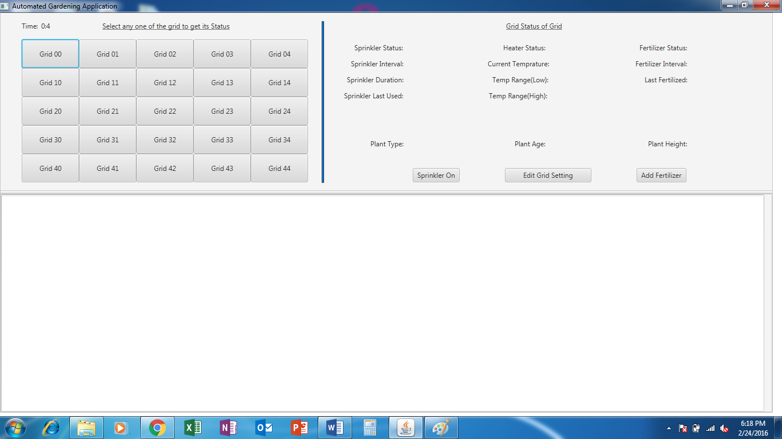

Figure 3: Main Page of Application

If you try to click on “Edit Settings” button without selecting any of the grid of which you intend to change, the you will be prompted to select a grind. The following image shows the situation.

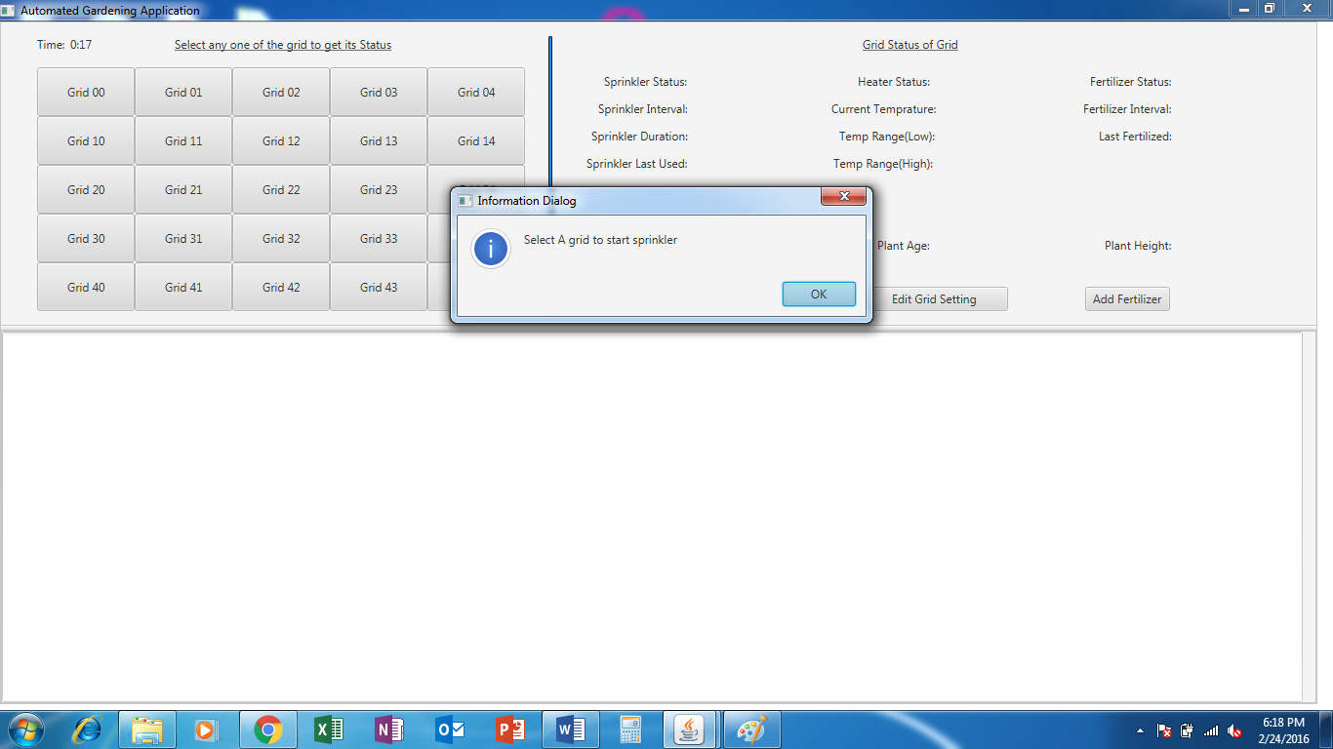

Figure 4: Select Grid Alert

Upon selecting any of the grid you will see the current status of the grid being displayed on the top right, shown below.

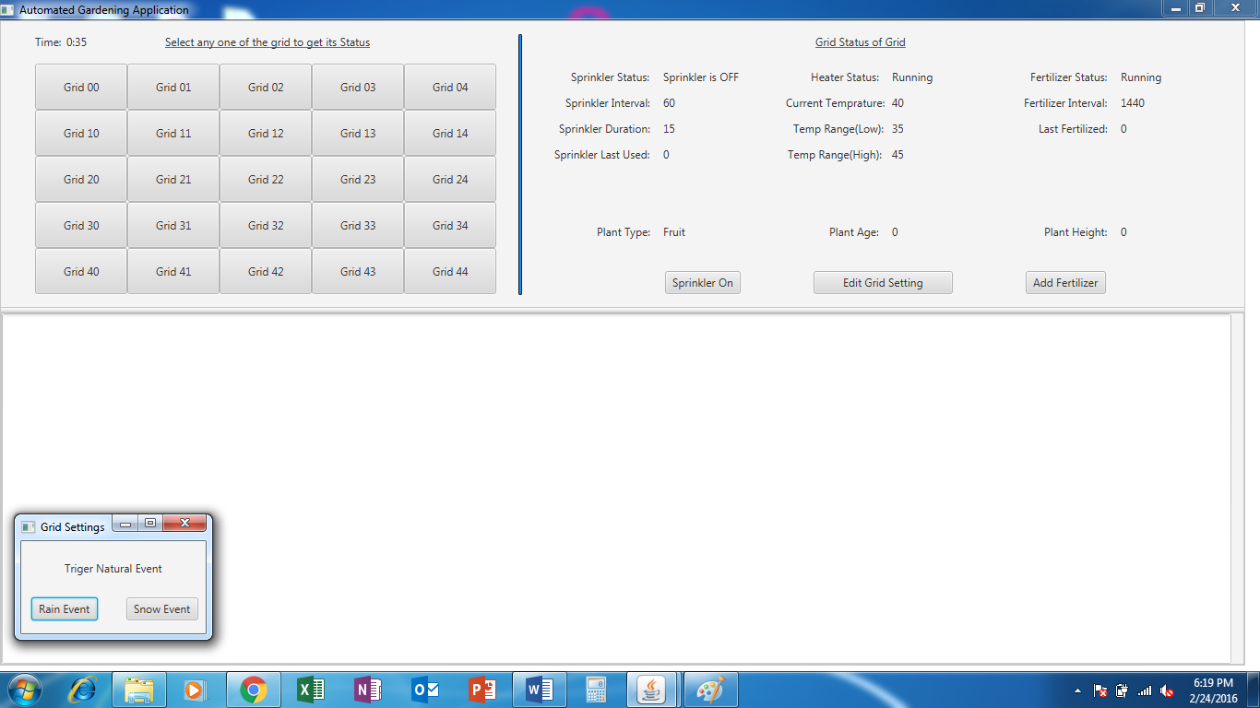

Figure 5: Current Status of Grid

* + 1. **Edit Settings of Grid:**

When you click on the “Edit Settings” button, then you will see a new window being opened where you can change the settings of the selected grid.

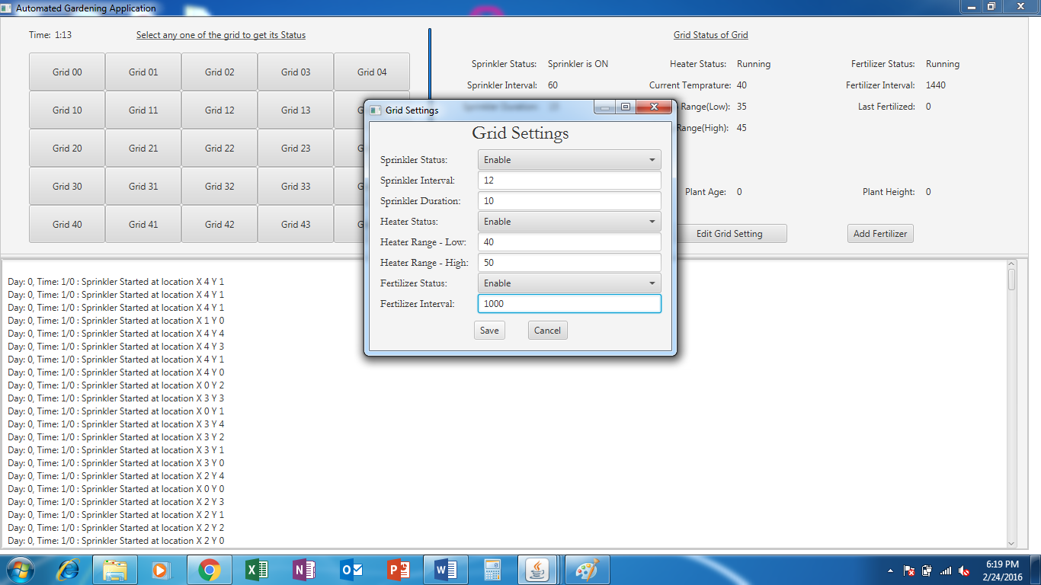

Figure 6: Edit Settings Window

* + 1. **Random Event Window:**

When you click on a grid you will see a Random Event Window pop out, this is just to initiate a Natural Event(Rain/ Show). This is show in the figure below.

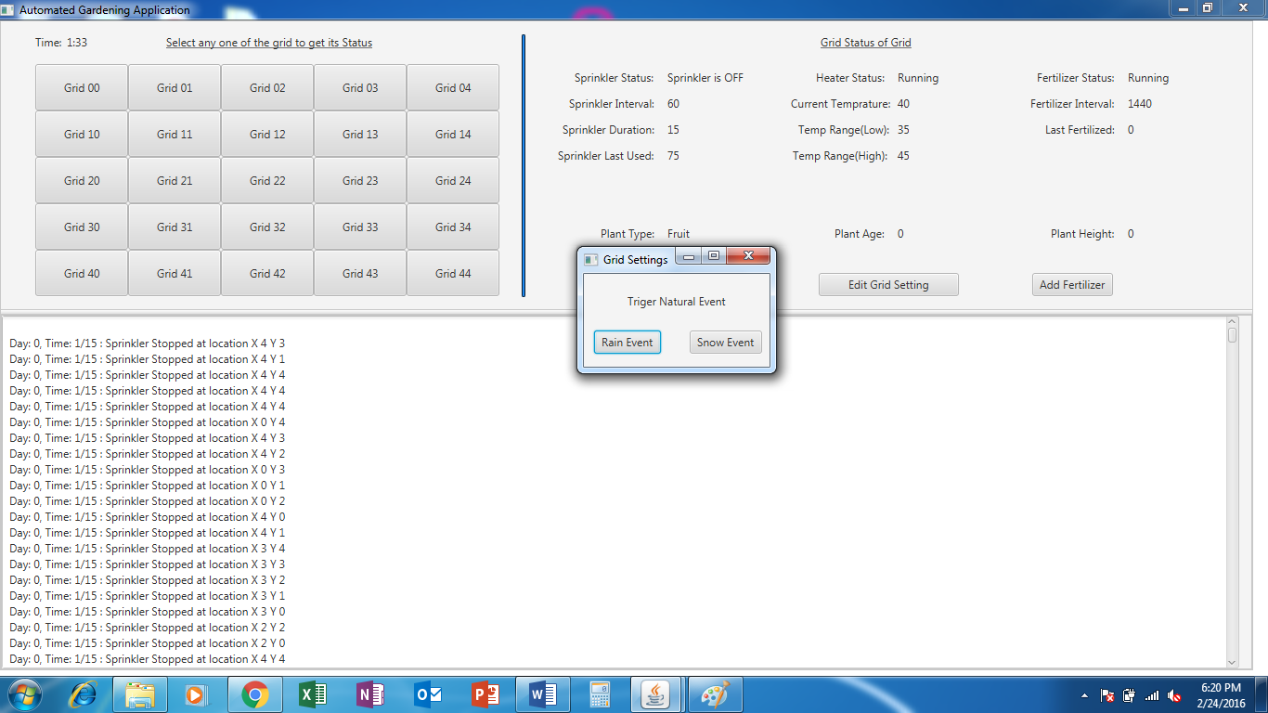

Figure 7: Random Event Window

* + 1. **Closing the Application:**

The application can be closed by clicking on the “X” mark on the Main Window.